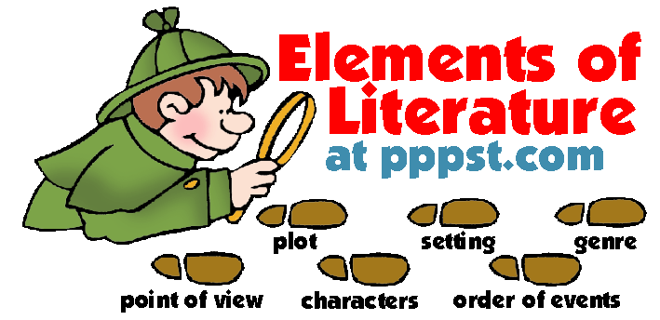
ELA Question Stems from Released Items by Standard
RL.1
What is implied by “quote from text”?
What can be inferred from paragraph#?
In this selection, what is the purpose of line#_?
What assumptions can the reader make about ____?
Based on paragraph#, what can be inferred about ____?
Which line from the text describes the speaker’s feelings about___?
RL.2
What does the speaker achieve with ____?
How does ____ help develop the theme?
How does the author introduce additional depth to ____ between the characters?
What is an objective summary of ___?
Which lines from the text support the theme?
RL.3
How has the speaker/character changed between ___ and ___?
What does ___ reveal about a character?
What is a possible reason a character does this?
How does the use of ____POV help the reader to understand ____?
What is the effect of the author’s use (overuse) of ___?
Based on paragraph#, what can be inferred about (character)?
RL.4
How does the use of (personification/imagery/ metaphor) help develop ___?
In paragraph#_, how does the connotation of the words reflect ___?
In this text, the use of the word ___, is meant to convey ___?
How does the author’s use of rhyme scheme (etc.) enhance the theme of the poem?
RL.6
How does the speaker/author/ character’s cultural background affect her perception of ____?
How does the speaker/author/ character’s point of view affect her impression of ____?
RL.5
What can be inferred from the statement below? (The answer choices refer to tension, surprise, mystery and suspense.)
RI.1
According to the text, why is ____ described/ considered?
What can be inferred from paragraph#_?
RI.2
Which statement summarizes the central idea of the text?
What can be inferred from the author’s use of ___ in the text?
What can be inferred from the author’s focus on ___?
RI.3
How does the author structure the text?
How does the author unfold the ideas about ___?
What is the significance of the structure of the text?
How does the author connect ideas in the text?
What is the author’s purpose in starting with ___ and then moving on the explain____?
Why does the author include the following sentence?
RI.4
What is the effect of the metaphor in the sentence below?
How does the author use language to____?
In paragraph#_, what effect does the word ___ have on the selection?
What is the effect of the phrase _____ on the overall selection?
What is the purpose of the figurative language in paragraph#?
RI.5
What is the significance of the statement____?
Which statement describes the connection of ___ to ___?
Why does the author include the following statement?
RI.6
Which groups of words from the selection conveys the author’s attitude about his topic?
How does the author achieve his purpose?
What is the author’s purpose in writing this selection?
How does the author use language to advance his point of view?
Why does the author choose to end the selection with ____? to start with ___?
L.4
What is the effect of the metaphor in the sentence below?
What is the meaning of the phrase ____?
W.1
How does the author use language to advance her point of view Use evidence to support.
Based on the selection, what can be inferred about (a character) character?
In ____, why does the author (use a specific device or make a specific writer’s choice)?
RL.1
What is the source of the narrator’s frustration?
What is implied by the character’s decision?
In paragraph #_, why does the narrator/speaker feel ____ as he _(does this)__?
RL.2
Which quote from the text represents the central idea?
RL.3
Which quote shows the narrator’s emotional development over the course of the text?
In paragraph#_, why did the narrator provide specific details about a character or event?
RL.4
Based on the text, which term has a similar meaning as the word ___ used in paragraph#_?
RL.5
What is the effect of the use of dialogue in the text?
Based on paragraph#, why does the author choose to use ___ in this text?
L.4
As used in paragraph#_, what is the speaker referencing with the word ____?
Based on the context, what substitution could be made for the word ___?
L.5
In paragraph#, how does the figurative language affect the tone of the text?
RL.1
Which quote characterizes ___?
Based on the details, what can be inferred about___?
How does (character) influence___?
What can be inferred about the relationship between ___ and ___?
What can be inferred from the text?
RL.2
Which statement objectively summarizes the text?
Explain how the author uses setting to develop the theme of the text?
RL.3
In the text, why is (character #1) disconcerted by the change in (character #2)?
What is the significance of the author’s emphasis on ____?
How does paragraph#_ affect the rest of the text?
How does the author create tension in the text?
RL.4
What is the effect of the use of the words ___?
What effect does repetition of ___ have on the meaning of the text?
RL.6
What does the narrator mean by ___ in paragraph#_?
Which detail explains the ironic situation between the characters?
L.4
Based on the context of paragraph#, what does the word ___mean?
In paragraph#_, what does ___ mean?
In paragraph#_, what does ___ reveal about ___?
L.5
What is the effect of the figurative language in paragraph#_?
How does the way characters are introduced affect the plot?

